Chapter 2 Review Sheet
Label the seafloor features in the diagram below
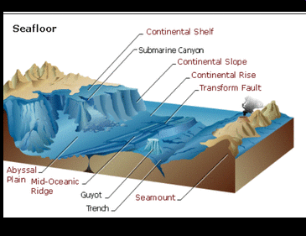
Matching
a. Pacific Ocean k. crust
b. Atlantic Ocean l. basalt
c. Indian Ocean m. granite
d. Arctic Ocean n. plate tectonics
e. Southern Ocean o. mid-ocean ridge
f. World Ocean p. continental drift
g. big bang q. trenches
h. density r. sea-floor spreading
i. core s. lithosphere
j. mantle t. athenosphere

1. the continental crust is made of this light colored mineral
2. the innermost layer of the earth
3. 2nd largest ocean basin
4. the layer outside the earth’s core
5. a continuous change of submarine volcanic mountains that encircles the globe like the seams on a baseball
6. the continuous body of water that surrounds Antarctica
7. Oceanographers often use this term to describe all the oceans together
8. smallest ocean basin
9. oceanic crust is made of this dark colored mineral
10. the outer most layer of the earth
11. a great cosmic explosion
12. a fairly rigid layer of the earth that is composed of the crust and the uppermost part of the mantle
13. the suggestion that all continents had once been joined in a single “supercontinent”, but have drifted apart.
14. a system of deep depressions in the seafloor
15. 3rd largest ocean basin
16. the process by which the sea floor moves away from the mid-ocean ridges to create new sea floor.
17. the process of the earth’s plates moving apart
18. the mass of a given volume of a substance
19. The largest and deepest ocean
20. the layer that the lithosphere floats on, it is the “plastic” layer

Matching
a. continental margins f. abyssal plain
b. continental shelf g. seamounts
c. continental slope h. guyots
d. continental rise i. hydrothermal vents
e. submarine canyons

21 a steep declining region of the sea floor
22. the deep-sea floor
23. eroded trenches found in the continental shelf
24. the division between the two main regions of the seafloor
25. the base of the continental slope
26. a shallow gentle slope of the sea floor
27. flat topped seamounts
28. submarine volcanoes conical in shape
29. a deep-sea hot spring

